The virtual datacenter: A network perspective
- What is a virtual datacenter?
- Who should implement a virtual datacenter?
- Considerations for implementing a virtual datacenter
- Virtual datacenter overview
Show 2 more
Applications migrated from on-premises might benefit from Azure's secure cost-efficient infrastructure, even with minimal application changes. Enterprises might want to adapt their architectures to improve agility and take advantage of Azure's capabilities.
Microsoft Azure delivers hyperscale services and infrastructure with enterprise-grade capabilities and reliability. These services and infrastructure offer many choices in hybrid connectivity, which allows customers to access them over the internet or a private network connection. Microsoft partners can also provide enhanced capabilities by offering security services and virtual appliances that are optimized to run in Azure.
Customers can use Azure to seamlessly extend their infrastructure into the cloud and build multitier architectures.

What is a virtual datacenter?
The cloud began as a platform for hosting public-facing applications. Enterprises recognized the value of the cloud and began migrating internal line-of-business applications. These applications brought more security, reliability, performance, and cost considerations that required more flexibility when delivering cloud services. New infrastructure and networking services were designed to provide flexibility. New features provide elastic scale, disaster recovery, and other considerations.
Cloud solutions were initially designed to host single, relatively isolated applications in the public spectrum, which worked well for a few years. As the benefits of cloud solutions became clear, multiple large-scale workloads were hosted on the cloud. Addressing security, reliability, performance, and cost concerns is vital for the deployment and lifecycle of your cloud service.
In the example cloud deployment diagram below, the red box highlights a security gap. The yellow box shows an opportunity to optimize network virtual appliances across workloads.
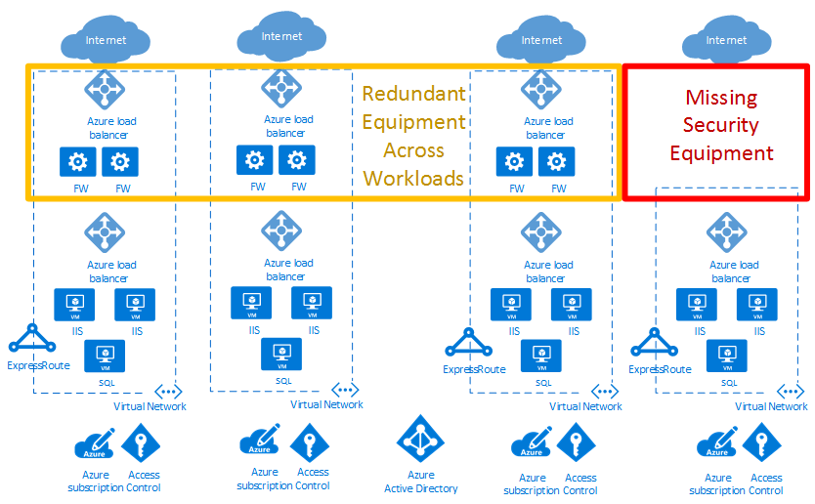
Virtual datacenters help achieve the scale required for enterprise workloads. The scale must address the challenges introduced when running large-scale applications in the public cloud.
A virtual datacenter implementation includes more than the application workloads in the cloud. It also provides network, security, management, DNS, and Active Directory services. As enterprises migrate more workloads to Azure, consider the infrastructure and objects that support these workloads. Good resource management helps avoid the increase of separately managed "workload islands" with independent data flows, security models, and compliance challenges.
The virtual datacenter concept provides recommendations and high-level designs for implementing a collection of separate but related entities. These entities often have common supporting functions, features, and infrastructure. Viewing your workloads as a virtual datacenter helps realize reduced cost from economies of scale. It also helps with optimized security via component and data flow centralization, and easier operations, management, and compliance audits.
Note
A virtual datacenter isn't a specific Azure service. Rather, various Azure features and capabilities are combined to meet your requirements. A virtual datacenter is a way of thinking about your workloads and Azure usage to optimize your resources and capabilities in the cloud. It provides a modular approach to providing IT services in Azure, while respecting the enterprise's organizational roles and responsibilities.
A virtual datacenter helps enterprises deploy workloads and applications in Azure for the following scenarios:
- Host multiple related workloads.
- Migrate workloads from an on-premises environment to Azure.
- Implement shared or centralized security and access requirements across workloads.
- Mix DevOps and centralized IT appropriately for a large enterprise.

Who should implement a virtual datacenter?
Any customer who decides to adopt Azure can benefit from the efficiency of configuring a set of resources for common use by all applications. Depending on the size, even single applications can benefit from using the patterns and components used to build a VDC implementation.
Some organizations have centralized teams or departments for IT, networking, security, or compliance. Implementing a VDC can help enforce policy points, separate responsibilities, and ensure the consistency of underlying common components. Application teams can retain the freedom and control that is suitable for their requirements.
Organizations with a DevOps approach can also use VDC concepts to provide authorized pockets of Azure resources. This method ensures the DevOps groups have total control within that grouping, at either the subscription level or within resource groups in a common subscription. At the same time, network and security boundaries stay compliant. Compliance is defined by a centralized policy in the hub network and centrally managed resource group.

Considerations for implementing a virtual datacenter
When designing a virtual datacenter, consider these pivotal issues:

Identity and directory service
Identity and directory services are key capabilities of both on-premises and cloud datacenters. Identity covers all aspects of access and authorization to services within a VDC implementation. To ensure that only authorized users and processes access your Azure resources, Azure uses several types of credentials for authentication, including account passwords, cryptographic keys, digital signatures, and certificates. Azure Active Directory Multi-Factor Authentication provides an extra layer of security for accessing Azure services. A strong authentication with a range of easy verification options (phone call, text message, or mobile app notification) allows customers to choose the method they prefer.
Large enterprises need to define identity management processes that describe the management of individual identities, their authentication, authorization, roles, and privileges within or across their VDC. The goals of this process might increase security and productivity, while reducing cost, downtime, and repetitive manual tasks.
Enterprise organizations might require a demanding mix of services for different lines of business. Employees often have different roles when involved with different projects. The VDC requires good cooperation between different teams, each with specific role definitions to get systems running with good governance. The matrix of responsibilities, access, and rights can be complex. Identity management in the VDC is implemented through Azure Active Directory (Azure AD) and Azure role-based access control (Azure RBAC).
A directory service is a shared information infrastructure that locates, manages, administers, and organizes everyday items and network resources. These resources can include volumes, folders, files, printers, users, groups, devices, and other objects. Each resource on the network is considered an object by the directory server. Information about a resource is stored as a collection of attributes associated with that resource or object.
All Microsoft online business services rely on Azure Active Directory (Azure AD) for sign-on and other identity needs. Azure Active Directory is a comprehensive, highly available identity and access management cloud solution that combines core directory services, advanced identity governance, and application access management. Azure AD can integrate with on-premises Active Directory to enable single sign-on for all cloud-based and locally hosted on-premises applications. The user attributes of on-premises Active Directory can be automatically synchronized to Azure AD.
A single global administrator isn't required to assign all permissions in a VDC implementation. Instead, each specific department, group of users, or services in the Directory Service can have the permissions required to manage their own resources within a VDC implementation. Structuring permissions requires balancing. Too many permissions can impede performance efficiency, and too few or loose permissions can increase security risks. Azure role-based access control (Azure RBAC) helps to address this problem by offering fine-grained access management for resources in a VDC implementation.

Security infrastructure
Security infrastructure refers to the segregation of traffic in a VDC implementation's specific virtual network segment. This infrastructure specifies how ingress and egress are controlled in a VDC implementation. Azure is based on a multitenant architecture that prevents unauthorized and unintentional traffic between deployments. This is done by using virtual network isolation, access control lists, load balancers, IP filters, and traffic flow policies. Network address translation (NAT) separates internal network traffic from external traffic.
The Azure fabric allocates infrastructure resources to tenant workloads and manages communications to and from Virtual Machines (VMs). The Azure hypervisor enforces memory and process separation between VMs and securely routes network traffic to guest OS tenants.

Connectivity to the cloud
A virtual datacenter requires connectivity to external networks to offer services to customers, partners, or internal users. This need for connectivity refers not only to the Internet, but also to on-premises networks and datacenters.
Customers control the services that can access and be accessed from the public internet. This access is controlled by using Azure Firewall or other types of virtual network appliances (NVAs), custom routing policies by using user-defined routes, and network filtering by using network security groups. We recommend that all internet-facing resources are protected by the Azure DDoS Protection Standard.
Enterprises might need to connect their virtual datacenter to on-premises datacenters or other resources. This connectivity between Azure and on-premises networks is a crucial aspect when designing an effective architecture. Enterprises have two different ways to create this interconnection: transit over the Internet or via private direct connections.
An Azure Site-to-Site VPN connects on-premises networks to your virtual datacenter in Azure. The link is established through secure encrypted connections (IPsec tunnels). Azure Site-to-Site VPN connections are flexible, quick to create, and typically don't require any more hardware procurement. Based on industry standard protocols, most current network devices can create VPN connections to Azure over the internet or existing connectivity paths.
ExpressRoute enables private connections between your virtual datacenter and any on-premises networks. ExpressRoute connections don't go over the public Internet, and offer higher security, reliability, and higher speeds (up to 100 Gbps) along with consistent latency. ExpressRoute provides the benefits of compliance rules associated with private connections. With ExpressRoute Direct, you can connect directly to Microsoft routers at either 10 Gbps or 100 Gbps.
Deploying ExpressRoute connections usually involves engaging with an ExpressRoute service provider (ExpressRoute Direct being the exception). For customers that need to start quickly, it's common to initially use Site-to-Site VPN to establish connectivity between a virtual datacenter and on-premises resources. Once your physical interconnection with your service provider is complete, migrate connectivity over your ExpressRoute connection.
For large numbers of VPN or ExpressRoute connections, Azure Virtual WAN is a networking service that provides optimized and automated branch-to-branch connectivity through Azure. Virtual WAN lets you connect to and configure branch devices to communicate with Azure. Connecting and configuring can be done either manually or by using preferred provider devices through a Virtual WAN partner. Using preferred provider devices allows ease of use, simplification of connectivity, and configuration management. The Azure WAN built-in dashboard provides instant troubleshooting insights that can help save you time, and gives you an easy way to view large-scale site-to-site connectivity. Virtual WAN also provides security services with an optional Azure Firewall and Firewall Manager in your Virtual WAN hub.

Connectivity within the cloud
Azure Virtual Networks and virtual network peering are the basic networking components in a virtual datacenter. A virtual network guarantees an isolation boundary for virtual datacenter resources. Peering allows intercommunication between different virtual networks within the same Azure region, across regions, and even between networks in different subscriptions. Traffic flows can be controlled inside and between virtual networks by sets of security rules specified for network security groups, firewall policies (Azure Firewall or network virtual appliances), and custom user-defined routes.
Virtual networks are anchor points for integrating platform as a service (PaaS) Azure products like Azure Storage, Azure SQL, and other integrated public services that have public endpoints. With service endpoints and Azure Private Link, you can integrate your public services with your private network. You can even take your public services private, but still enjoy the benefits of Azure-managed PaaS services.

Virtual datacenter overview

Topologies
A virtual datacenter can be built using one of these high-level topologies, based on your needs and scale requirements:
In a Flat topology, all resources are deployed in a single virtual network. Subnets allow for flow control and segregation.
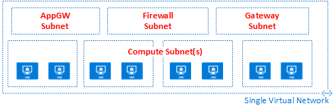
In a Mesh topology, virtual network peering connects all virtual networks directly to each other.
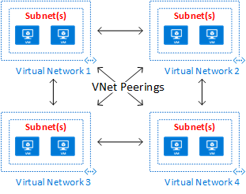
A Peering hub and spoke topology is well suited for distributed applications and teams with delegated responsibilities.
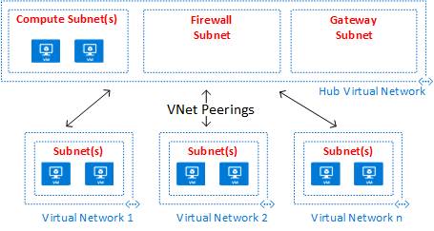
An Azure Virtual WAN topology can support large-scale branch office scenarios and global WAN services.
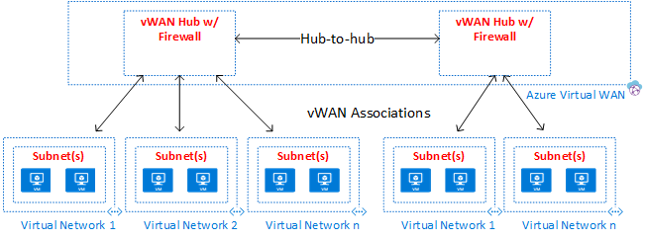
The peering hub and spoke topology and the Azure Virtual WAN topology both use a hub and spoke design, which is optimal for communication, shared resources, and centralized security policy. Hubs are built using either a virtual network peering hub (labeled as Hub Virtual Network in the diagram) or a Virtual WAN hub (labeled as Azure Virtual WAN in the diagram). Azure Virtual WAN is designed for large-scale branch-to-branch and branch-to-Azure communications, or for avoiding the complexities of building all the components individually in a virtual networking peering hub. In some cases, your requirements might mandate a virtual network peering hub design, such as the need for network virtual appliances in the hub.
In hub and spoke topologies, the hub is the central network zone that controls and inspects all traffic between different zones such as the internet, on-premises, and the spokes. The hub and spoke topology helps the IT department centrally enforce security policies. It also reduces the potential for misconfiguration and exposure.
The hub often contains common service components consumed by the spokes. The following examples are common central services:
- The Windows Active Directory infrastructure is required for user authentication of third parties that access from untrusted networks before they get access to the workloads in the spoke. It includes the related Active Directory Federation Services (AD FS)
- A Distributed Name System (DNS) service is used to resolve naming for the workload in the spokes and to access resources on-premises and on the internet if Azure DNS isn't used
- A public key infrastructure (PKI) is used to implement single sign-on on workloads
- Flow control of TCP and UDP traffic between the spoke network zones and the internet
- Flow control between the spokes and on-premises
- If needed, flow control between one spoke and another
A virtual datacenter reduces overall cost by using the shared hub infrastructure between multiple spokes.
The role of each spoke can be to host different types of workloads. The spokes also provide a modular approach for repeatable deployments of the same workloads. Examples include dev/test, user acceptance testing, preproduction, and production. The spokes can also segregate and enable different groups within your organization. DevOps groups are a good example of what spokes can do. Inside a spoke, it's possible to deploy a basic workload or complex multitier workloads with traffic control between the tiers.

INTRODUCTION

Big data is a term used to describe huge volume of data, generated by digital process and media exchange all over the world. Google file system and Hadoop distributed file system were developed and implemented to handle huge amount of data. Big data challenges such as velocity, variety, volume and complexity were taken into consideration when GFS and HDFS were developed. Google came up first with the design of GFS and published it in white papers, then after Apache open-source developed Hadoop based on Google’s white papers. How GFS and HDFS work and manage data flow will BBE explain. For both file systems, a comparison was made on many levels and criteria. The GFS and HDF’S architecture including database engines, components, data flow and many other creterias were tackled and discussed.
MAIN GOAL OF GFS AND HDFS
The HDFS and GFS were built to support large files coming from various sources and in a variety of formats. Huge data storage size (Peta bytes) are distributed across thousands of disks attached to commodity hardware. Both HDFS and GFS are designed for data-intensive computing and not for normal end-users¹. Data-intensive computing is a class of parallel computing used to process and analyze large amount of data referred to as big data. Data reliability is achieved through distribution architecture, even when failures occur within chunk servers, master or network partitions. There is no limit to the cluster that you can have. The size can be increased anytime as per the need.
GOOGLE FILE SYSTEM
GFS architecture and components: The GFS is composed of clusters. A cluster is a set of networked computers. Figure 1 shows that, GFS clusters contain three types of interdependent entities which are: Client, master and chunk server. Clients could be: Computers or applications manipulating existing files or creating new files on the system. The master server is the orchestrator or manager of the cluster system that maintain the operation log. Operation log keeps track of the activities made by the master itself which helps reducing the service interruptions to a minimum level. At startup, master server retrieves information about contents and inventories from chunk servers. Then after, the master server keeps tracks of the location of the chunks with the cluster. The GFS architecture keeps the messages that the master server sends and receives very small. The master server itself doesn’t handle file data at all, this is done by chunk servers. Chunk servers are the core engine of the GFS. They store file chunks of 64 MB size. Chunk servers coordinate with the master server and send requested chunks to clients directly.
GFS replicas: The GFS has two replicas: Primary and secondary replicas. A primary replica is the data chunk that a chunk server sends to a client. Secondary replicas serve as backups on other chunk servers. The master server decides which chunks act as primary or secondary. If the client makes changes to the data in the chunk, then the master server lets the chunk servers with secondary replicas, know they have to copy the new chunk off the primary chunk server to stay in its current state.
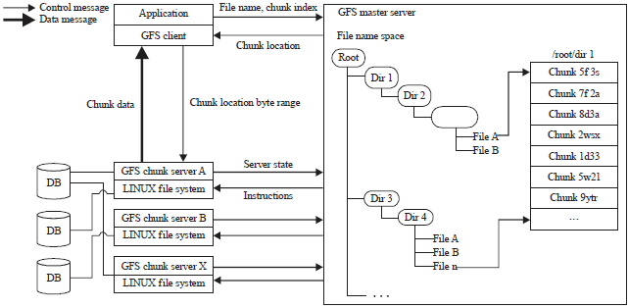
Fig. 1: | Google file system architecture

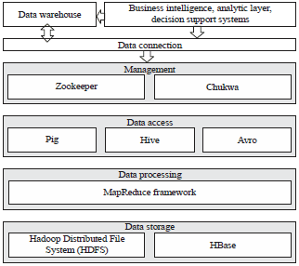
Fig. 2: | Hadoop components

MapReduce: MapReduce is a programming model developed by Google and used by both GFS and HDFS. Based on Google MapReduce white paper, Apache adopted and developed its own MapReduce model with some minor differences. The primary role of MapReduce is to provide an infrastructure that allows development and execution of large-scale data processing jobs. Therefore, MapReduce exploits the processing capacity provided by computing clusters while, at the same time offering a programming model that simplifies the development of such distributed applications. MapReduce make the decomposition of tasks and integration of results. It provides job trackers and task trackers.
MapReduce is a programming model Google has used successfully to process big data. A map function extracts intelligence from raw data and a reduce function aggregates the data output by map. MapReduce needs a distributed file system and an engine that can distribute, coordinate, monitor and gather the results.
The HDFS is a master and slaver framework which contains nodes and NameNode. The NameNode is a center server that manages the namespace in the file system. The data node manages the data stored in it.
HADOOP DISTRIBUTED FILE SYSTEM
First of all, it should by clearly state that Hadoop has Google origins. Based on three white papers published by Google, which are: "Google file system²", "MapReduce: Simplified data processing on large clusters³" and "Bigtable: A distributed storage system for structured data⁴", Apache developed Apache HDFS, Apache MapReduce and Apache HBase, respectively. Almost 95% of the architecture described in these three white papers is implemented in Apache projects with some minor differences. Google released these white papers with no code. So, it was up to engineers and scientists at Apache to design and implement the architecture.
Hadoop components: Hadoop has the following components, as shown also in Fig. 2.
Zookeeper: A centralized service for maintaining configuration information, naming, providing distributed synchronization and providing group services.
Chukwa: An open source data collection system for monitoring large distributed systems. Chukwa is built on top of the Hadoop Distributed File System (HDFS) and MapReduce framework and inherits Hadoop’s scalability and robustness.
Pig: A platform for analyzing large data sets that consists of a high-level language for expressing data analysis programs, coupled with infrastructure for evaluating these programs.
Hive: The Apache Hive data warehouse software facilitates querying and managing large datasets residing in distributed storage. Hive provides a mechanism to project structure onto this data and query the data using a SQL-like language called HiveQL.
Avro: Apache Avro is a data serialization system. It has rich data structures. A compact, fast and binary data format. It acts as a container file, to store persistent data. It also provides simple integration with dynamic languages.
MapReduce: Hadoop MapReduce has the same architecture and functionality of Google MapReduce but the difference is that Hadoop MapReduce was written in Java and GF’S MapReduce was written in c++.
Moreover, not to forget that Google’s original version of MapReduce work only with GFS file system but Hadoop’s version can work with many file systems since it was adopted by Apache open-source project hence used in many architectures.
HBase | : | Apache HBase is the Hadoop database, a distributed scalable and big data store
HDFS | : | Hadoop file system is a core component in the Hadoop architecture. The HDFS sits in the data storage layer in Hadoop. The HDFS and HBase will be explained in more details in the coming sections

Underlying file system: The HDFS is the distributed file system of Hadoop. What HDFS does is to create an abstract layer over an underlying existing file systems running on the machine. Underlying file systems might be ext3, ext4 or xfs.
Hadoop architechture: Since Hadoop comes from Google white papers, it has the same master/slave architecture but in different implementation. Hence, all processes or services in the Hadoop file system are classified as slave or master.
MasterNode-HDFS nodes
NameNode: Hadoop has only one NameNode (master node of the file system) which is a single point of availability failure, so if it goes down the DataNode will lose control for blocks.
Every slave machine will run a DataNode daemon and also run a TaskTracker daemon for MapReduce. NameNode stores the metadata of files saved on DataNodes. It is responsible for the namespace of the filesystem.
Hadoop 2.0 has also active/passive architecture for the NameNode. When active NameNode fails, a passive NameNode takes place within few seconds. This passive secondary NameNode is not really a good solution and does not really act as redundant to the primary NameNode, thus it is not a high availability to the primary NameNode.
The primary NameNode, which keeps all the filesystem metadata in RAM has no capability to persist this metadata onto the disk.
Once the NameNode crashes, all the data in RAM are lost. What the secondary NameNode actually does is to contact the primary NameNode every 1 h, copy the metadata in RAM, reshuffles and merges it into a clean file called a checkpoint. The checkpoint file is then written or updated on the secondary NameNode.
JobTracker: JobTracker receives job request from client and manages MapReduce jobs. It monitors and detects failures in task allocation. Hadoop cluster has one JobTracker only.
Slave node-MapReduce nodes
DataNode: DataNodes are the hardware machine running in Hadoop cluster. Usually built from inexpensive commodity, they are used to store data blocks and send them to clients. DataNodes report periodically the list of data blocks to the primary NameNode.
TaskTracker: TaskTrackers are Java-based virtual machine developed to run tasks allocated by the JobTracker in MapReduce. Usually TaskTrackers run better on the same node of the DataNode, which maximizes data bandwidth. If the above best-practice is not available, TaskTrackers are placed on different nodes within the same rack in cluster. In worst cases, if the alternative scenario is not also available, TaskTracker is placed on a different rack within the cluster.
COMPARISION BETWEEN GFS AND HDFS
Scalability: Both HDFS and GFS are considered as cluster based architecture. Each file system runs over machines built from commodity hardware. Each cluster may consist of thousands of nodes with huge data size storage.
Implementation: Since GFS is proprietary file system and exclusive to Google only, it can not be used by any other company.
In the other part, HDFS based on Apache Hadoop open-source project can be deployed and used by any company willing to manage and process big data.
Yahoo! might be the most famous example where clusters are managed by Hadoop with HDFS file system inside. Yahoo! has more than 100,000 CPU in 40,000 computers running Hadoop. Their biggest cluster contains around 4500 nodes.
Facebook uses Hadoop to store copies of internal logs and dimension data sources and uses it as a source for reporting/analytics and machine learning. They currently have two major clusters:
• | A 1100-machine cluster with 8800 cores and about 12 Petabytes raw storage
• | A 300-machine cluster with 2400 cores and about 3 Petabytes raw storage

EBay uses Apache on 532-machine cluster with Apache HBase for search optimization and research.
Twitter, LinkedIn, Adobe, A9.com (Amazon) and many other websites use Hadoop to store and process data logs, batch jobs, processes for internal usage and structured data storage on hundreds of clusters with thousands of nodes each.
File serving: In GFS, files are divided into units called chunks of fixed size. Chunk size is 64 MB and can be stored on different nodes in cluster for load balancing and performance needs. In Hadoop, HDFS file system divides the files into units called blocks of 128 MB in size⁵. Block size can be adjustable based on the size of data.
Internal communication: Communication between chucks and clusters within GFS is made through TCP connections. For data transfer, pipelining is used over TCP connections. The same method is in HDFS, but Remote Procedure Call (RPC) are used to conduct external communication between clusters and blocks.
Cache management: In GFS, cache metadata are saved in client memory. Chunk server does not need cache file data. Linux system running on the chunk server caches frequently accessed data in memory.
The HDFS has "DistributedCache". DistributedCache is facility provided by the MapReduce to distribute application-specific, large, read-only files efficiently. It also caches files such as text, archives (zip, tar, tgz and tar.gz) and jars needed by applications.
DistributedCache files can be private or public, that determines how they can be shared on the slave nodes.
"Private" DistributedCache files are cached in a local directory private to the user whose jobs need these files.
"Public" DistributedCache files are cached in a global directory and the file access is setup in sucha way that they are publicly visible to all users.
Files protection and permission: Suitebriar-Google partner-mentions in its security analysis research that GFS splits files up and stores it in multiple pieces on multiple machines. File names have random names and are not human readable. Files are obfuscated through algorithms that change constantly. The HDFS implements POSIX-like mode permission for files and directories. All files and directories are associated with an owner and a group with separate permissions for users who are owners, for users that are members of the group and for all other users.
Replication strategy: The GFS has two replicas: Primary replicas and secondary replicas.
A primary replica is the data chunk that a chunk server sends to a client.
Secondary replicas serve as backups on other chunk servers. User can specify the number of replicas to be maintained.
The HDFS has an automatic replication rack based system. By default two copies of each block are stored by different DataNodes in the same rack and a third copy is stored on a DataNode on a different rack.
File namespace:
• | In GFS, files are organized hierarchically in directories and identified by path names
• | The GFS is exclusively for Google only
• | The HDFS supports a traditional hierarchical file organization
• | Users or application can create directories to store files inside
• | The HDFS also supports third-party file systems such as CloudStore and Amazon Simple Storage Service (S3)

Filesystem database: In this section, highlight one core component in the architecture of GFS and Hadoop; the database engine.
The GFS has bigtable database. Bigtable is a proprietary database developed by Google using c++.
Based on "Bigtable" study white papers, Apache developed its own database called HBase in Hadoop open-source project⁶. The HBase is built with Java language. The major common features between bigtable and HBase.
Big data: Ability to handle big amounts of data in a scalable manner.
No-SQL: Non relational database and not SQL based. The HBase is column-oriented database and bigtable is three-dimensional mapping database; it maps row key, column key and timestamp into one arbitrary byte array, hence the naming.
Atomicity: They both have atomic transactions in read, write and update.
Access control: Bigtable enforces access control on column family level with three aspects: Authentication, authorization and audit. This feature was not enabled in HBase until May, 2014.
Cell versioning and custom timestamps are found in HBase and bigtable using adjustable timestamps.
Batch writes: Batch write and batch table operations plus row filtering when scanning rows.
Block cache: Bigtable and HBase provide block cache. When reading blocks from storage files are cached internally.
Table 1: | Bigtable anf HBase comparison
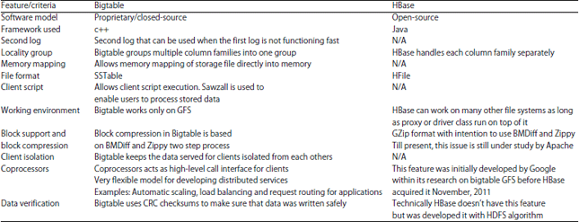

In Table 1, key differences between Apache’s HBase and Google’s bigtable are listed. Some are still under development by Apache due to the fact that HBase came after and was built according bigtable specs.
DATA FLOW INPUT AND OUTPUT
GFS read I/O:
• | Read requests are sent by clients to master in order to find out where a particular file on the system is stored
• | Master server replies back with the location for the chunk server acting as the primary replica holding the chunk
• | The master server provides a lease to the primary replica for the desired chuck
• | If the lease is not held by any replica, the master server defines a chuck as primary and chooses the closest chunkserver to client. That chunkserver becomes the primary
• | Finally, the client contacts the desired chunkserver directly, which sends the data to the client

GFS write I/O:
• | The client sends a request to the master server to allocate the chunkserver acting as the primary replica (Fig. 3)
• | The master sends to the client the location of the chunkserver replicas and identifies the primary replica
• | The client sends the write data to all the replicas chunk server’s buffer, starting with the closest. Data sent through pipeline
• | Once the replicas receive the data, the client tells the primary replica to begin the write function
• | The primary replica writes the data to the appropriate chuck and then the same is done on the secondary replica
• | The secondary replica completes the write function and reports back to the primary replica
• | Finally, the primary replica sends the confirmation to the client

HDFS read I/O:
• | Client asks the NameNode about block’s location
• | NameNode has metadata for all blocks location. It sends blocks’ location back to the client
• | Client seeks and retrieves the blocks directly from DataNode where the blocks are placed

HDFS write I/O:
• | The client sends a block write request to the NameNode (Fig. 4)
• | The NameNode responds back by telling on which DataNodes the file’s blocks should be written
• | Directly, HDFS client contacts the first DataNode over TCP and sends "Ready" command. The first DataNode by its turn sends it to the second DataNode and the same process continues for the third DataNode
• | "Ready" command is sent from the third DataNode to the second one and finally to the first DataNode which delivers it to the client telling all DataNodes are ready for the write order
• | The TCP pipeline is now ready to transfer the data block
• | The client sends the first block wishing to write directly to the first DataNode, then the second and finally third DataNode
• | All DataNodes update the NameNode about the written block
• | First DataNode tells the client that file’s block was written successfully
• | Then after, the client repeats the same scenario for the rest of data blocks

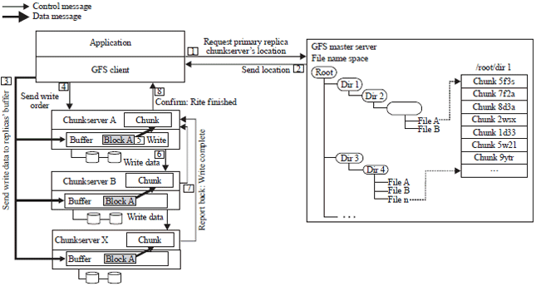
Fig. 3: | GFS write I/O

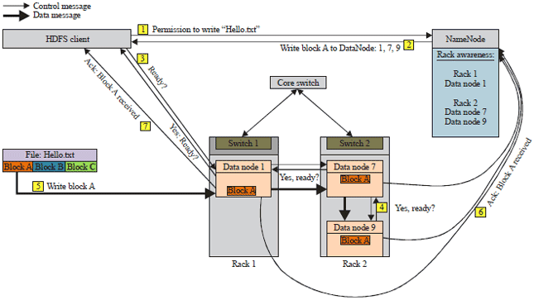
Fig. 4: | HDFS write I/O

MATERIALS AND RESULTS
Results of GFS and HDFS comparison can be resumed in the Table 2.
Table 2: | Summary comparison
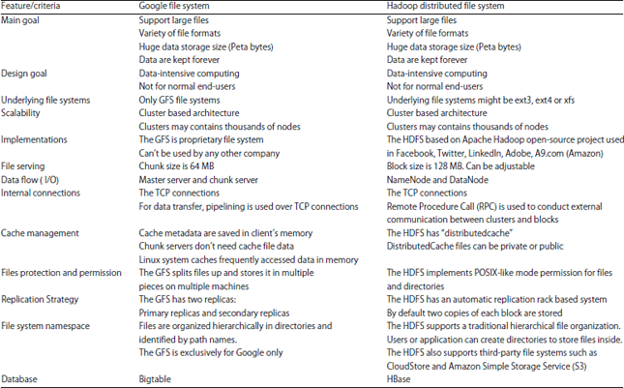

DISCUSSION

Table 2 summarized the differences and commonalities between GFS and HDFS. The GFS and HDFS share many common features, but are also different in some ways. Google was the leader in big data management and design before Apache came up with their open-source project.
Large companies like facebook and Ebay relies on HDFS to manage their huge amount of data. Apache is still improving HDFS hence, becoming one of the biggest open-source projects ever developed.

CONCLUSION

Big data is increasing frequently hence becoming one of the major trends and challenges in information technology and dealing with it requires tailored-made file systems and hardware architecture, built on robust framework and platforms.
Distributed file system are still in their early phase evolution.
Coda, XtreemFS, AFS, lustre, ceph and many more are good examples of newly developed DFS.
It’s up to the company’s data engineers to choose and implement DFS based on their needs or to design and develop their own architecture as Google did.

https://www.citrix.com/blogs/2022/05/23/application-virtualization-vs-desktop-virtualization-comparison/

What is File Level and Block Level Storage in Virtualization Concepts?
Apr 24, 2021 File Level, Block Level, Storage, Virtualization, Cloud , 15709 Views
In This Article, we'll discuss What is File-Level and Block-Level Storage in

File Level and Block Level Storage
To understand how RAID is used as the building block for data center storage, it is first important to understand the concepts of block storage and file storage. The difference between block-level storage and file-level storage is how the storage is organized and accessed on the storage device and from other devices, such as servers.
In block-level storage, a storage device such as a hard disk drive (HDD) is identified as something called a storage volume. A storage volume can be treated as an individual drive, a “block”. This gives a server's operating system the ability to have access to the raw storage sections. The storage blocks can be modified by an administrator, adding more capacity when necessary, which makes block storage fast, flexible, and reliable.
Note: Depending on the operating system used, storage volumes may be referred to with a different name. For example, Linux refers to storage volumes as physical volumes.
File-level storage is a type of storage that has a file system installed directly onto it where the storage volumes appear as a hierarchy of files to the server, rather than blocks. This is different from block type storage, which doesn't have a default file system and needs to have an administrator create one in order for non-administrator users to navigate and find data.

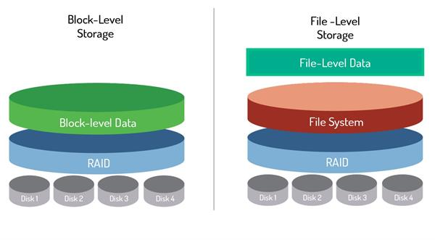

One benefit of using file storage is that it is easier to use. Most people are familiar with file system navigation as opposed to storage volumes found in block-level storage, where more knowledge about partitioning is required to create volumes.
Partitioning is the creation of sections on a disk that are set aside for certain files or software. Based on the operating system used, the partitions will be assigned a name or letter. For example, the letter C: is given to the main partition on Windows devices. This may seem familiar as most PCs purchased from a store have pre-configured hard drives with default partitions. However, for block storage devices purchased on their own, the user will most likely need to partition the drive before a file system can be installed as they do not come pre-configured with default partitions.

